Security Models

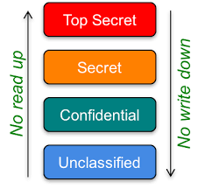

1. **Bell-LaPadula Model**
2. **Biba Model**
3. **Clark Wilson Model**
4. **Brewer and Nash Model**
5. **Harrison Ruzzo Ullman Model**

1 Bell - LaPadula Model

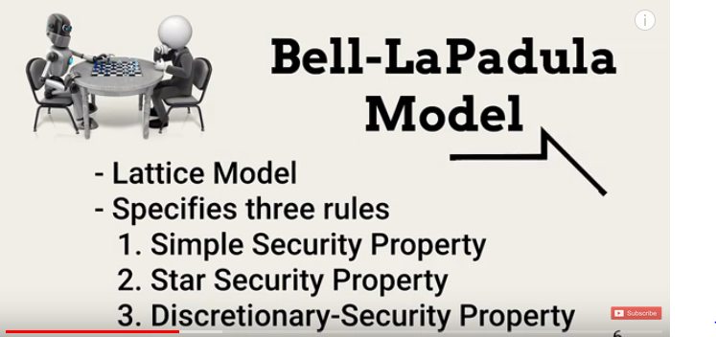

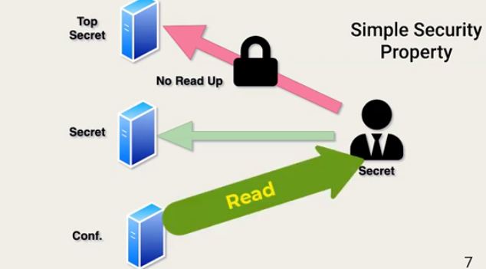

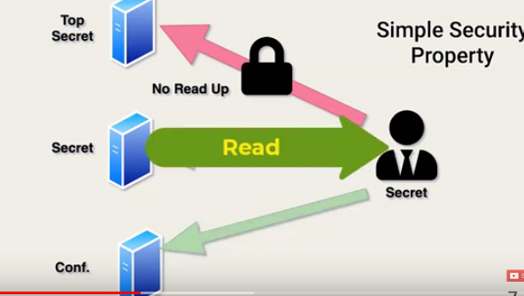

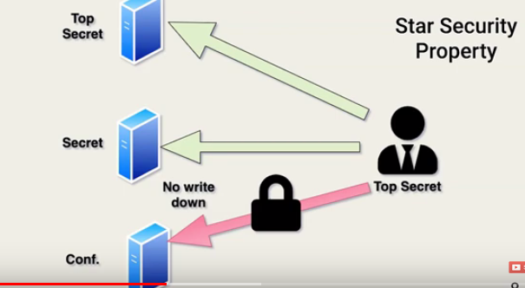

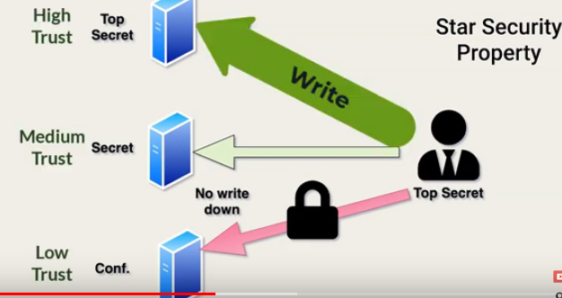

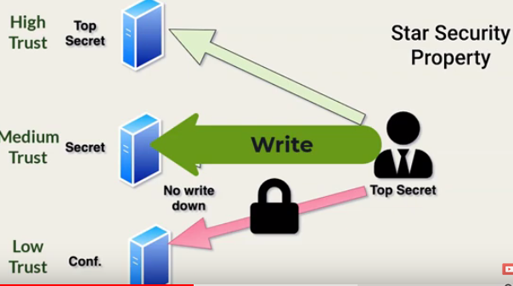

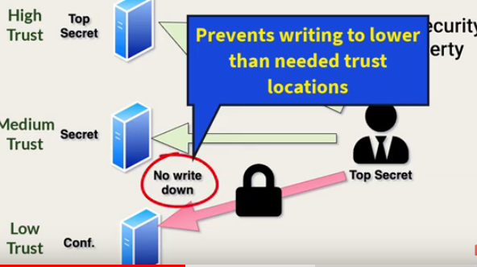

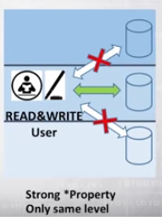

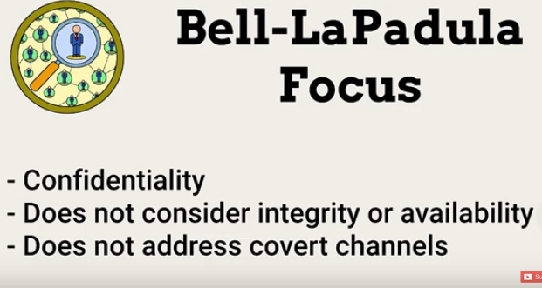

1. **Biba Model**

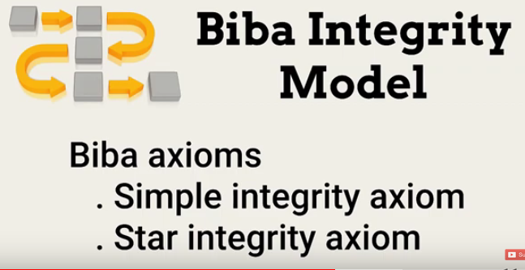

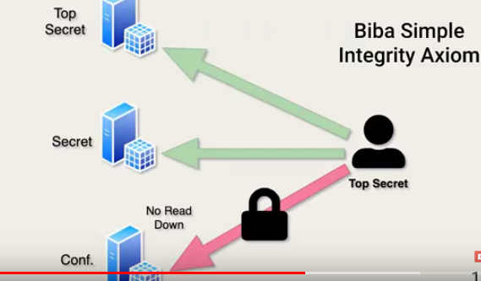

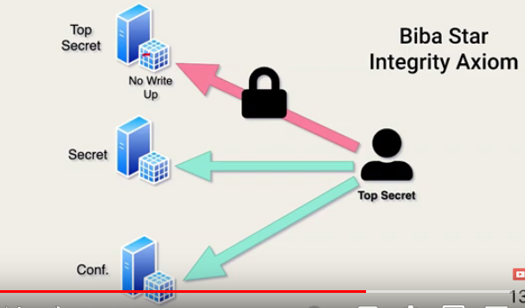

1. **Clark - Wilson Model**

**The Clark Wilson Model is dealing with two kinds of objects and we called one is CDIs and UDIs i.e. constrained data items and unconstrained data items. It also has two types of relations, the first one is IVP which means the Integrity veriﬁcation procedure and the second one is TP i.e. transaction procedure. The IVP’s work is to ensure that TPs causing CDIs are in a right state, and valid transformation certifies for all TPs.**

**Here, only TPs that are Only authorized can control CDIs. In other words, to protect the integrity of information and to ensure correctly formatted transactions, this integrity model should be well implemented**.

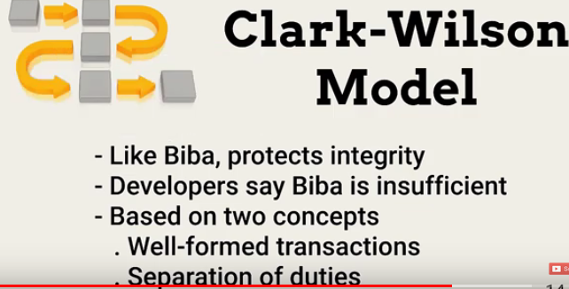

1. **Brewer- Nash Model**

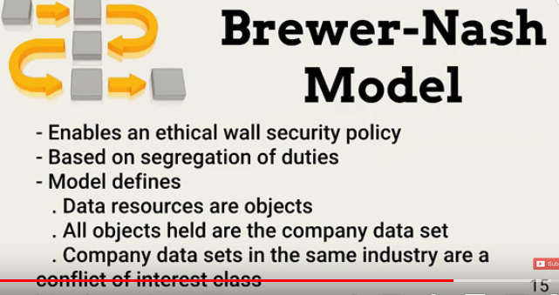

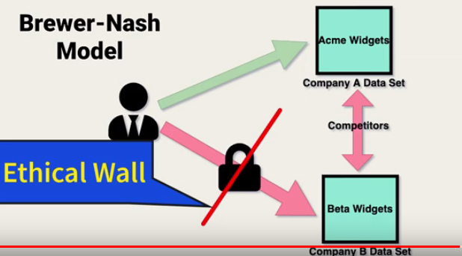

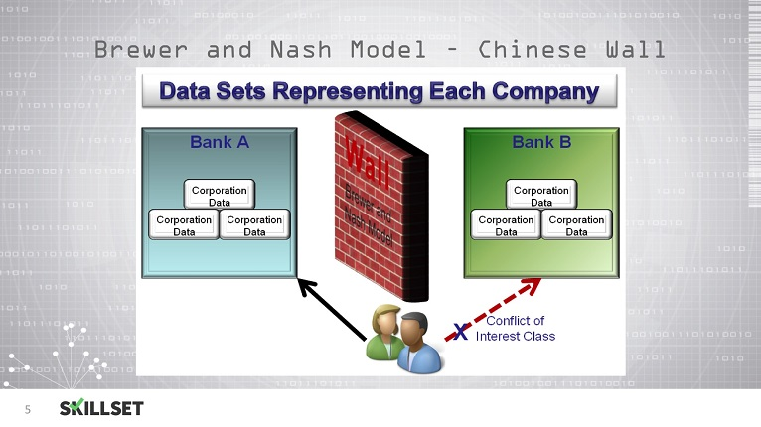

1. **Harrison Ruzzo Ullman Model**

**The security model proposed by Harrison, Ruzzo, and Ullman (HRU) is a discretionary access control model. In HRU, the current set of access rights at any given time can be represented by a matrix, with one row for each subject and one column for each subject and object (all subjects are also objects).**



